(Approx. 440 words)

Sort a List of Names in Microsoft Word

By Howard Lewis, Midland Computer Club, MI

http://mcc.apcug.org/

Webbyte (at) yahoo.com

Lists of names are usually entered into Word, either in First Name Last Name (Tom Smith) or Last Name, First Name (Smith, Tom) order, with each name a separate paragraph (i.e. followed by pressing the Return key when entered).

If the names are entered First Name Last Name and then sorted within Word, the list will sort based on the First Name:

Before sorting:

Tom Smith
Mary Brubaker
Joe Adams
Kara Jones
Walter Allen
Mary Ann Baker

After sorting:

Joe Adams
Kara Jones
Mary Brubaker
Mary Ann Baker
Tom Smith
Walter Allen

To accomplish this simple sort, simply highlight the group of names, click on the Sort icon within the Paragraph group on the Ribbon (Figure 1)

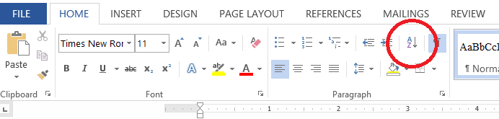
Figure 1. Sort icon in Ribbon

and set Sort by to Paragraph, Type to Text, and order Ascending (Figure 2)

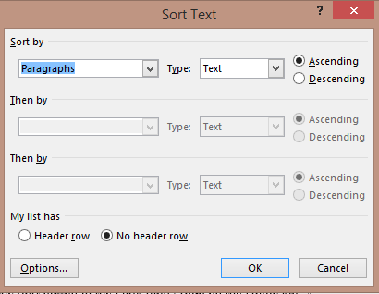
Figure 2. Sort Text Dialog Box

Frequently though, we wish to sort the list based on the Last Name instead of First Name. In this case, the names can either be entered Last Name, First Name (so we would sort as above) or they can be entered as in the first case (First Name Last Name). If the names are entered First Name Last Name, we must handle the list somewhat differently. You still will select the list of names and click on the Sort icon on the Ribbon. Now you need to click on the Options button at the bottom of the dialog box (Figure 3).

Figure 3. Sort Options Dialog Box

In the Sort Options box, you need to select Other and replace anything which may be in the following text box with a Space and then click OK. Now, in the Sort Text dialog box, click on the drop-down arrow under Sort by and select Word 2. (Figure 4) and click OK.
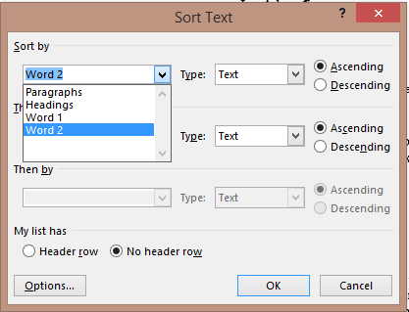
Figure 4. Sort Text Dialog Box

The following example shows the end results of sorting by Last Name. One more thing to note. We have a name that has more than two parts (Mary Ann Baker). Even though it looks like it is three words, a nonbreaking space (Ctrl+Shift+Space) has been inserted between Mary and Ann. This makes Mary Ann appear to be one word to Microsoft Word.

Now, starting with the above list:
Tom Smith
Mary Brubaker
Joe Adams
Kara Jones
Walter Allen
Mary Ann Baker

And sorting by the last name, we get:
Joe Adams
Walter Allen
Mary Ann Baker
Mary Brubaker
Kara Jones
Tom Smith

